Bulletin Blub # 1 – Program Introduction – run for 3 weeks starting 19 May

Blessed Trinity Parish presents
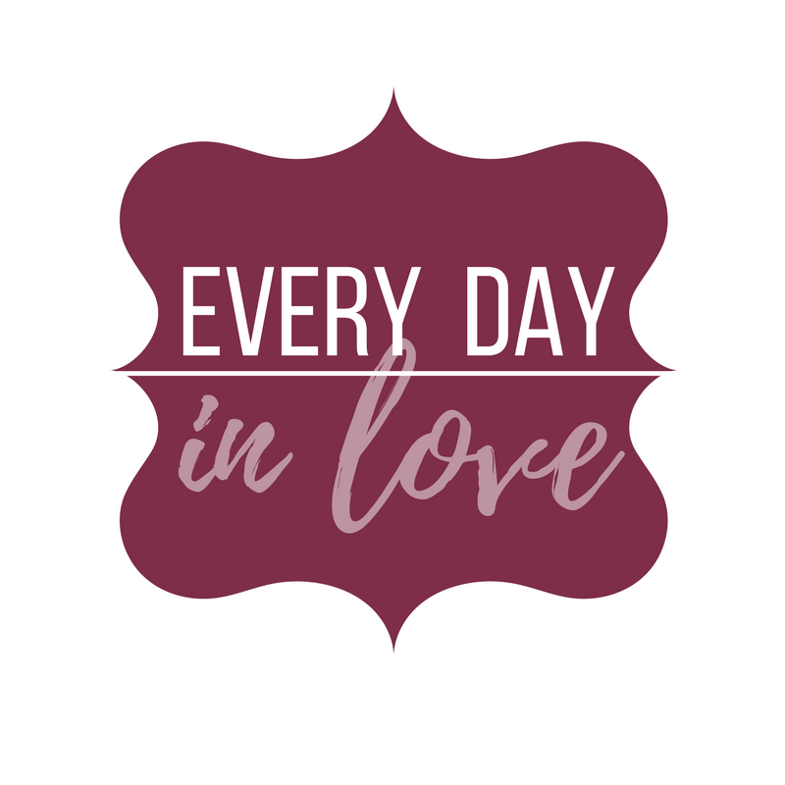
Do not miss these four, up-beat, engaging, and empowering mini workshops designed to release joy and enthusiasm in every couple’s relationship – every day!

“Smart Loving” “The Passionate Couple”
“Talking with Purpose” “Living the Dream”
Each are packed with practical strategies, everyday skills, liberating insights, and experiential exercises and include state of the art printed material. Authors and new parishioners of Blessed Trinity, Ron and Kathy Feher will share stories from their own life and teach from a wealth of experience of over 40 years of helping couples of all ages to live more passionate and joyful marriages. Every Day in Love empowers couples to live “in love” consistently, not just for their own sake but for the sake of those around them.
Saturday mornings: July 14, July 21, August 4, August 11: 8:30 AM- Noon in the Parish Hall, includes continental breakfast. While the ideal is to make all four, each session can stand alone. Every day in Love is open to all! For more information or to register online go to www.livinginlove.org/our-programs/every-day-in-love or register in person at the parish office.
Can’t make the live session at the parish? Experience it at home via video streaming or DVD format anytime!

Bulletin Blub # 2 – Program Specific Information – run for 5 weeks starting 9 June

Blessed Trinity Parish Presents
Register Now! Do not miss these four, fun, engaging and transformational mini workshops designed to release joy in every couple’s relationship! Saturday mornings: 8:30 -Noon in the Parish Hall, including continental breakfast. While the ideal is to make all four, each session can stand alone and is open to all!
Smart Loving - July 14: When we are “in love” we are other –centered and joyful. Integrate fascinating insights from the sciences with rich spirituality. Set yourself up for success by filling out a special “gift registry” that can help you discover what makes your husband or wife feel most “in love”!
The Passionate Couple - July 21: Take your relationship to the next level! Uncover the secrets to living passionately in love as soul mates rather than settling for getting along.
Talking with Purpose - August 4: Experientially learn verbal skills to achieve a powerful emotional connection, avoid misunderstanding, heal hurts, and grow closer rather than apart.
Living the Dream - August 11: Learn a fool proof process that can absolutely avoid ever having another argument and help a couple come together on any issue in a tender atmosphere. Develop couple values and plan to live in love on purpose!
For more information and to register go to www.livinginlove.org/our-programs/every-day-in-love or register in person at the parish office. Cost is $5 per person per session to cover materials. Parish scholarships available upon request.
Can’t make the live session at the parish? Experience it at home via video streaming or DVD format anytime

Bulletin Blub # 3 – Session 1 specific – weekend of 7-8 July

Blessed Trinity parish presents:
Almost here! Don’t miss “Every Day in Love” this coming Saturday morning! Register online at www.livinginlove.org/our-programs/every-day-in-love or register in person at the parish office.

Smart Loving- July 14, 8:30 AM – Noon in our Parish Hall, continental breakfast included.

A proactive common-sense approach to inviting more joy into our lives by helping us love smarter. Fascinating insights from the sciences help us embrace other-centered generosity and prioritize nurturing the atmosphere of being in love. Gain clarity and freedom from our common “dumb loving” mistakes including those elusive “unspoken expectations.” Set yourself up for success by filling out a special “gift registry” that will help you discover what makes your husband or wife feel most in love! When we are “in love” everything in marriage is easier!

Can’t make the live session at the parish? Experience it at home via video streaming or DVD format anytime! www.livinginlove.org/our-programs/every-day-in-love/#ordering%20 materials

Bulletin Blub # 4 – Session 2 specific – weekend of 14-15 July

Don’t miss the next “Every Day in Love” this coming Saturday morning!

The Passionate Couple- July 21, 8 AM – Noon in our own Parish Hall, continental breakfast included. Register online at www.livinginlove.org/our-programs/every-day-in-love or register in person at the parish office. Cost is only $10 per couple per session.
Take your relationship to the next level! This session offers a paradigm shift from just getting along to being passionately in love, not just for our own sake but for the sake of those around us. It offers keen insights that bridge the gap between how men and women prefer to achieve intimacy and empowers us to become spiritual soul mates as a sacramental couple. Put exciting meaning into both our everyday and most intimate communication.
If you did not attend the previous session, you may still participate in Session 2.
Can’t make the live session at the parish? Experience it at home via video streaming or DVD format anytime! www.livinginlove.org/our-programs/every-day-in-love/#ordering%20 materials

Bulletin Blub # 5 – Session 3 specific – weekend of 30-31 July

Don’t miss the next “Every Day in Love” this coming Saturday morning!

Talking with Purpose- August 4, 8:30 AM – Noon in our own Parish Hall, continental breakfast included. Register online at www.livinginlove.org/our-programs/every-day-in-love or register in person at the parish office. Cost is only $10 per couple per session.
This session offers simple strategies to help us avoid misunderstanding and teaches a powerful skill that can achieve an emotional connection; so that, we can feel close in any situation. Learn practical approaches for reconciling hurts and freeing ourselves from outside pressures. The issue is not the issue; we are the issue! If we are not growing closer, we are growing apart. To grow closer, we need different tools for different situations or to affect different purposes.
If you have not attended any of the previous session, you may still participate in Session 3.
Can’t make the live session at the parish? Experience it at home via video streaming or DVD format anytime! www.livinginlove.org/our-programs/every-day-in-love/#ordering%20 materials

Bulletin Blub # 6 – Session 4 specific – weekend of 4-5 August

Don’t miss the next “Every Day in Love” this coming Saturday morning!

Living the Dream- August 11, 8:30 AM – Noon in our own Parish Hall, continental breakfast included. Register online at www.livinginlove.org/our-programs/every-day-in-love or register in person at the parish office. Cost is only $10 per couple per session.
Learn a fool proof process that can help a husband and wife to come together on any issue while still nurturing the tender atmosphere of being in love. This session can help us absolutely avoid ever having an argument and unleashes an aura of deep respect in our marriage. Never fight to win because then you have to sleep with a loser! It will also guide us in discerning and directing our lives intentionally; so that, we can live in love the way we always dreamt we would.
If you have not attended any of the previous sessions, you may still participate in Session 4.
Can’t make the live session at the parish? Experience it at home via video streaming or DVD format anytime! www.livinginlove.org/our-programs/every-day-in-love/#ordering%20 materials

Registration Form

His Name: ………………………………………………………………………………………..

Her Name: ……………………………………………………………………………………….

Parish: …………………………………………………………

Contact Information:
Email: ……………………………………………………………………………………
Phone: ……………………………………………………………
Address: ………………………………………………………………………………..
City: ………………………………………… State: …………. Zip: ……………

All four sessions (14 Jul, 21 Jul, 4 Aug, 11 Aug) Discounted total cost $35 per couple

Session 1 – Smart Loving (14 Jul) Single session cost $10 per couple

Session 2 – The Passionate Couple (21 Jul) Single session cost $10 per couple

Session 3 – Talking with Purpose (4 Aug) Single session cost $10 per couple

Session 4 – Living the Dream (11 Aug) Single session cost $10 per couple

Checks payable to PMRC. Scholarships available on request.

Total amount collected: …………………………………………..

